National University of “Kyiv-Mohyla Academy”

Master’s Program:

“Information Management Systems and Technologies”

Master’s Thesis

Ensuring Interoperability of Electronic Learning Materials
by Extending SCORM Standard
(Забезпечення інтероперабельності електронних
навчальних матеріалів за рахунок розширення SCORM стандарту)

Author:
Second Year Student
Olena Chesanovska

Supervisor:
Senior Lecturer
Andriy Glybovets

Kyiv 2009
Contents
1 Introduction 4
2 Research Problem 5
2.1 Background Information 5
2.2 Urgency 9
2.3 Research Purpose 11
3 SCORM 12
3.1 Scorm Overview 12
3.2 History 13
3.3 Commonly Used Terms in SCORM 14
3.4 Conceptual Starting Point For SCORM 16
3.5 Learning Management Systems 17
3.6 Content Aggregation Model 19
3.6.1 SCORM Content Model 19
3.6.1.1 Asset 19
3.6.1.2 Sharable Content Object 20
3.6.1.3 Activities 21
3.6.1.4 Content Organization 22
3.6.1.5 Content Aggregation 24
3.6.2 Content Packaging 25
3.6.2.1 Content Packaging Overview 25
3.6.2.2 Content Package Components 26
3.6.2.3 Components of a Manifest 28
3.6.2.4 Building Content Packages 33
3.6.2.5 SCORM Content Package Application Profiles 38
3.6.3 Metadata 41
3.6.3.1 LOM Metadata Creation 42
3.6.3.2 LOM XML Schema Validation Approaches 43
3.6.3.3 Metadata Extensions 48
3.6.3.4 Metadata and SCORM Content Model Components 49
3.6.4 SCORM Sequencing and Presentation 57
3.6.4.1 Sequencing and Presentation 57
3.6.4.2 Presentation/Navigation Information 58
3.6.4.3 Relationship to Content Packaging 59
4 Learning materials processing example 61
5 Summary 70
6 REFERENCES 72

List of Abbreviations
ADL Advanced Distributed Learning
AICC Aviation Industry Computer-Based Training Committee
CAM Content Aggregation Model
DC Dublin Core
DCed Dublin Core Education Working Group
DCMES Dublin Core Metadata Element Set
DCMI Dublin Core Metadata Initiative
TDT Document Type Definition
IEEE Institute for Electrical and Electronics Engineers
IMS Information Model Specification
LMS Learning Management System
LOM Learning Object Metadata
LTSC Learning Technology Standards Committee
PAPI Public and Private Information
PDA Personal digital assistant
RTE Run-Time Environment
SCO Sharable Content Object
SCORM Sharable Content Object Reference Model
SN Sequence and Navigation
XML Extensible Markup Language
XSD XML Schema Definition

Introduction
Recently a considerable move from traditional education towards e-learning has been observed. This process has already passed its earliest phases, for efforts of standardisation of it have already taken place. The main notable achievement in the standardization of certain processes associated with distance learning was reached by the creation of the model SCORM (Sharable Content Object Reference Model). The standard consists of specifications that provide interoperability, accessibility and reusability of web-based learning content.
SCORM describes a “Content Aggregation Model” and a “Run-Time Environment” for instructional objects to support adaptive instruction based on a learner's goals, preferences, prior performance and other factors. SCORM also describes a “Sequencing and Navigation” model for the dynamic presentation of content based on learner needs.
Distance learning has already set roots in Ukraine also. With fast acceptance and implementation of e-learning by means of Learning Management System, namely Moodle, at Ukrainian universities, standardization is an urgent question for today.
So, SCORM can be a powerful solution within an organization, but even more so across organizations. Key guarantees of SCORM are accessibility and reusability of content. Providing reusability, SCORM at the same time ensures interoperability for SCORM conformant systems.
SCORM provides means of representation of learning material taxonomy in Organizations component. Besides, it leaves space and instructions for its extending. Extending SCORM content organization in depth by defining curricular taxonomy not only in Manifest, as defined by the standard, but also providing specifically organized resources – learning documents in XML format – can bring the following advantages:
- Interoperability as guaranteed by SCORM – no standard requirements are violated, and XML document is accepted and recognized as a resource by SCORM; moreover, XML is based on international standards, therefore is recognized by all.
- Step towards intellectualization of the Learning Management System – an agent could choose and return the learner information from the structured document depending on the student’s model, e.g. according to his or her rates, studied courses.
- Possible solution for m-learning – it is not convenient to study large amounts of information from mobile devices; consequently, full learning materials are not efficient for m-learners. Providing a learner a possibility to select and view only the necessary amount of information can be a good solution.
Instructors should be suggested means of automatic creation of XML versions of their learning materials.

Research Problem

Background Information
In the last few years remarkable efforts have been observed in the design and development of Web-Based Educational Environments (WEE) that exploit the possibilities of new technologies and adapt the processes of teaching and learning to modern educational reality.
Education has seen important developments in the last decades and continues, at a regular and careful pace, to incorporate new methods and techniques in the educational process. New possibilities, such as asynchronous education, are cultivated and developed at very quick rates. New terms, such as virtual classrooms, distance-learning, and adaptive education, most of which derived mainly from technological developments, have been added to educational terminology. There is no doubt that the field of education is one of the most rapidly developing sectors of modern society. Today, more often than ever we hear about distance learning, asynchronous education via the internet, continuous education and individualised learning.
Despite the positive progress and the innovations that have contributed to distance learning, there have been a lot of problems. These problems arise mainly from the lack of satisfactory standards and specific rules that would not only ensure the rendering of quality education, but also its future development. The main notable effort in the standardisation of certain processes associated with distance learning was realised in the last few years with the creation of the model SCORM. This model can constitute the foundation and the beginning for the development of distance learning via the internet, as it determines specific rules for many subjects, while at the same time being flexible enough and susceptible to a lot of improvements [1].
SCORM is a collection of specifications that enable interoperability, accessibility and reusability of web-based learning content. SCORM content can be delivered to learners via any SCORM-compliant Learning Management System (LMS) using the same version of SCORM. The standard contains requirements to the organization of learning material and whole distance learning management system [2].
The main advantages of SCORM are centred on the continuous updating of students' progress in the course, the benefit of more freedom in students' activities and choices, the dynamic creation of adaptation of courses, as well as the existence of specific tools for the development of instructive material [1].

SCORM in comparison with other standards
It is necessary to mention that SCORM is not the only attempt to standardize e-learning and processes connected with it.
First, I find it important to name Dublin Core (DC), which is an international and interdisciplinary attempt to develop interoperable online metadata standards that support a broad range of purposes and business models. Its DC-Education Application Profile module describes usage of DCMI properties specifically relevant to education. The phrase "application profile module" refers to the scope of the profile: it only includes properties relevant to describing the educational aspects of any resource, and/or the educational context within which it has been or may be used. The Dublin Core Metadata Element Set (DCMES) is a vocabulary of fifteen properties for use in resource description. Main DC metadata elements are divided on 3 groups that correspond to the class of stored information: elements describing resources content, elements touching intellectual property, and elements concerning resources identification. DC elements compound almost all metadata systems at the moment, but are not practically used in original form [3].
The IEEE LOM standard defines a set of meta-data elements that can be used to describe learning resources. This includes the element names, definitions, datatypes, and field lengths. The standard is known as a multi-part standard and defines both a conceptual model for the meta-data and an XML binding. The standard includes conformance statements for how meta-data documents must be organized and how applications must behave in order to be considered IEEE-conformant. The IEEE provides roughly 64 metadata elements that can be used to describe SCORM Content Model Components [4].
Metadata used to describe SCORM Content Model Components is directly based on the IEEE 1484.12.1-2002 Learning Object Metadata (LOM) [4] standard and the IEEE 1484.12.3 Standard for Extensible Markup Language (XML) Binding for Learning Object Metadata Data Model [5] (and on AICC, IMS Global, and Ariadne). So, comparing SCORM with DCMI specifications, we can compare IEEE LOM and DCMI extended specifications.
DCMES & IEEE LOM [6]
- Both share a resource discovery role
  - Discovery defines the boundaries of the DCMES/DCEd role
  - Discovery is the jumping off point for more complex object management processes in IEEE
- Metadata instances
  - IEEE LTSC assumes a monolithic metadata record for an object
  - DCMI assumes modular metadata packages for an object stemming from potentially different organizations and communities of practice (and the potential logical aggregation of those packages)

Both pursue following common goals:
  - Agreement for honoring namespaces
  - Mechanisms for integrating DCMES/DC-ED and IEEE LOM elements in an application profile
  - Mechanisms for cooperation in the evolution of metadata for educational objects
Because DC standard appears to be more general and simple, it is usually extended with own set of elements, mostly quite large set, which is not desirable; while LOM standard was developed specially for educational objects. The fact that many development organizations already support the latter in their products also says in favour of LOM [7].
All in all, almost every metadata system used in education is based either on extended DC specifications, or on LOM specification with some minor modifications.
One more standard I would like to mention is The LTSC Public and Private Information (PAPI). PAPI specification is devoted to support the exchange of learner data between different systems [8]. It specifies both the syntax and semantics of a 'Learner Model,' which will characterize a learner and his or her knowledge/abilities. But it is necessary to emphasize that PAPI concentrates on the learner, while SCORM deals with learning content. Nevertheless, PAPI can be useful for expected future intellectualization of LMS.
To sum this section up, it is necessary to say that all standards work on interoperability and reusability issues, and cooperate with each other in order to enable high-quality, accessible, and affordable learning experiences. As far as SCORM has been created namely for e-learning, concerns learning materials, covers content, runtime environment, metadata, and is based on several progressive international standards, it has been selected for investigation in the scope of the thesis.

Compatibility of SCORM with Moodle
SCORM 1.2 is supported in Moodle 1.9.3 and Moodle 1.8.7 and passes all the tests in the ADL Conformance test suite 1.2.7 for SCORM 1.2.
SCORM 2004 is not completely supported in Moodle at this stage. Parts of the API have been implemented, but others such as Navigation and Sequencing have not yet been implemented.
M-learning
As computers and the internet become essential educational tools, the technologies become more portable, affordable, effective and easy to use. M-learning can do much to enrich the learning experience. By blending more conventional learning with mobile phones, PDAs and handhelds, one can experience flexible learning that extends the use of ICT beyond the classroom. It is widely believed that mobile learning could be a huge factor in getting disaffected young adults to engage in learning, where more traditional methods have failed. As mobile phones combine PDA functions with cameras, video and MP3 players, and as tablets combine the portability of PDAs with the functionality of desktops, the world of learning becomes more mobile, more flexible and more exciting [9].
By enabling learning on the go, m-learning is the perfect solution for today’s mobile community, especially taking into account the fact that the latter has grown to 4 milliard people in 2008. This has been declared by International Telecommunication Union, a specialized UNO institution. The quantity of mobile communication users is expected to increase to 5 milliard people by the end of 2012 according to “Подробности”. This statistics makes mobile learning even more reasonable [10, 11].
SCORM for M-learning
SCORM for m-learning does not exist for today yet. Navigation problems stand for stumbling block. Below points demonstrate the two obstacles in showing the SCO in the PDA [12]:
- SCORM played inside the windows. The page is generated with iframes, than can't be visualized in the PDA.
- SCORM played in a new window. The window is open as a popup and this doesn't work with the PDA.

Urgency
Importance and advantages of distance learning (DL) have been investigated and accepted by Ukrainian staff. As a result, near 30 % educational institutions have declared their plans to organize learning in the DL mode in Ukraine [13]. National University “Kyiv-Mohyla Academy” is one of the pioneers in this sphere in our country. It is time to think of standardisation of the processes concerning distance learning.
Nowadays’ distance education in Kyiv-Mohyla Academy is based on Moodle platform. The latter is one of the LMSs that support content organized according to SCORM. So, having learning materials under SCORM we can guarantee their accessibility, interoperability and reuse.
The fundamental objective of model SCORM is to structure the material in such a way so as to be accessible and reusable by many. So, the standard itself provides interoperability.
Actually, SCORM supports a wide class of learning materials types, that is video and audio files, images, text. But each type has its handling peculiarities, thus coverage of all of them in this work is impossible. Despite the fact that multimedia materials are very important in the educational process, it is worth mentioning that most learning information is given as text. That is why in my thesis I will concentrate namely on text material processing.
What I suggest – is extending SCORM content organization in depth, including the representation of curricular taxonomy not only in Manifest, as defined by the standard, but also providing structured organization leave items – learning documents in XML format. Such approach can benefit us in the following:
- Interoperability as assured by SCORM
- In prospect, intellectualization of the LMS – we assume an agent that would select the necessary information from the structured document based on the student’s model, namely on his or her rates, studied courses.
- Some solution for m-learning – user can select the necessary amount of information to be learned from mobile device and decide whether he or she needs more material to be studied from PC.
More details on the suggested approach, implementation and benefits can be found in practical part of the thesis.

Research Purpose
To extend SCORM standard in order to automate and intellectualize LMS, ensuring interoperability of the content and providing possible learning material solution for m-learning.

SCORM

Scorm Overview
What is SCORM?
Increasingly, people are receiving training and education through their computers. The Shareable Content Object Reference Model is a technical specification that governs (using software languages like XML and ECMA script) how this online training (or “e-learning”) is created and delivered to learners.
Two essential software systems are required to facilitate e-learning. The first is the actual instructional material, or “content”. The other is a Learning Management System which is responsible for directing the learner to relevant training, tracking the learner’s progress (things like score and current location) and maintaining the learner’s transcript. The essence of SCORM is that any content that conforms to the SCORM specifications will work with any SCORM conformant LMS [14].
The Sharable Content Object Reference Model defines a specific way of constructing Learning Management Systems and training content so that they work well with other SCORM conformant systems. Basically, the different versions of SCORM all govern the same two things: packaging content and exchanging data at runtime [15].
Packaging content determines how a piece of content should be delivered in a physical sense. At the core of SCORM packaging is a document titled the "imsmanifest". This file contains every piece of information required by the LMS to import and launch content without human intervention. This manifest file contains XML that describes the structure of a course both from a learner’s perspective and from a physical file system perspective. Questions like, "Which document should be launched?" and "What is the name of this content?" are answered by this document.
Runtime communication, or data exchange, specifies how the content ”talks” to the LMS while the content is actually playing. This is the part of the equation we describe as delivery and tracking. There are two major components to this communication. First, the content has to "find" the LMS. Once the content has found it, it can then communicate through a series of "get" and "set" calls and an associated vocabulary. Conceptually, these are things like "request the learner’s name" and "tell the LMS that the learner scored 95% on this test." Based on the available SCORM vocabulary, many rich interactive experiences can be communicated to the LMS.
SCORM seeks to knit together the contributions of disparate groups and interests in the distributed learning community. It is intended to coordinate emerging technologies and capabilities with commercial/public implementations [16].

Why should I use SCORM?
SCORM is a really powerful tool for anyone involved in online training. Content can be created one time and used in many different systems and situations without modification. This plug-and-play functionality can be powerful within an organization but even more so across organizations. Content can be sold and delivered to the user more quickly, more robustly, and at a lower price [15].
Up-front investment is required to develop and convert learning content for technology-based presentation. These investment costs may be reduced by an estimated 50-80 percent through the use of learning content that is accessible, interoperable, durable and reusable [16].

What is SCORM NOT?
SCORM governs online training only, and only between a single user and the system. Offline training does not apply, nor does group training [15].
SCORM doesn’t specify instructional design, pedagogical methods, visual appearance or anything else that affects the educational experience [14].
SCORM remains intentionally silent on many things as well. Window size, cosmetic appearances, reporting… these items belong to the LMS or the content, and are not commented on at all.

History
SCORM was created in the year 2000 by a US Department of Defence organization called ADL. It is now widely adopted and is the de facto industry standard. To date, there are three released versions of SCORM, each building on top of the prior one [14].
- SCORM 1.1 was essentially the first pass, and never gained wide acceptance. Some products still support it, but it is not widely adopted.
- SCORM 1.2 followed on 1.1, and solved many of 1.1’s problems. It was and is the widely adopted version. As of May 2006, every major LMS continues to support it, and the majority of content vendors still produce content that meets the 1.2 specification.
- SCORM 2004 (formerly known as SCORM 1.3) is the most recent release. It formalizes the 1.2 specification and provides a key addition known as Sequencing and Navigation. S&N allows the content vendor to specify both the behaviour within the SCO and the behaviour between the SCOs. This allows for substantially richer content interactions and huge increases in the reuse of SCOs. Adoption has been slow, to this point, but the number of vendors supporting SCORM 2004 is increasing greatly.

Commonly Used Terms in SCORM
Below is a list of commonly used terms throughout the SCORM books and their definitions.
SCORM Run-Time Environment (RTE) Application Program Interface (API): The communication mechanism for informing the LMS of the state of a content object (e.g., initialized, finished, in an error condition). The API is used for getting and setting data (e.g., score, time limits, etc.) between the LMS and the Sharable Content Object (SCO).
Assets: Assets are electronic representations of media, such as text, images, sound, web pages or other pieces of data that can be delivered using web technologies.
Content Organization: A standardized way to describe the structure and behaviour of content.
Content Packaging: A standardized way to identify and exchange digital resources between different systems or tools. Content packaging can also define content organizations.
SCORM Run-Time Environment (RTE) Data Model: A standard set of data elements used to define the information being communicated, such as, the status of the learning resource. In its simplest form, the data model defines elements that both the LMS and SCO are expected to “know about.” The LMS must maintain the state of required data elements across sessions, and the learning content must utilize only these predefined data elements if reuse across multiple systems is to occur.
Learning Management System (LMS): Software that automates training event administration through a set of services that launches learning content, keeps track of learner progress, sequences learning objects, and reports student mastery.
Metadata: Information about content that includes descriptions of characteristics and relationships among category items.
Asset Metadata: Metadata can be applied to Assets to provide descriptive information about the Assets independent of any usage or potential usage within courseware content. This metadata is used to facilitate reuse and discoverability, within, for example, a content repository during content creation.
Content Organization Metadata: Content Organization Metadata describes the Content Organization. The purpose of applying Content Organization Metadata is to enable discoverability within, for example, a content repository and to provide descriptive information about the content structure, as a whole, defined by the Content Organization.
Sharable Content Object (SCO) Metadata: Metadata can be applied to SCOs to provide descriptive information about the content in the SCO independent of use. This metadata is used to facilitate reuse and discoverability of content.
Sharable Content Object (SCO): A collection of one or more assets that represents a single launchable resource that can communicate with an LMS using the SCORM RTE. A SCO represents the lowest level of granularity of learning resources that can communicate with an LMS using the SCORM RTE.
The Sharable Content Object Reference Model (SCORM®): A collection and harmonization of specifications and standards that defines the interrelationship of content objects, data models, and protocols such that objects are sharable across systems that conform to the same model.
SCORM Content Aggregation Model (CAM): A common method to describe the components used in a learning experience, how to package those components for exchange from system to system, how to describe those components to enable search and discovery, and how to define sequencing rules for the components.
SCORM Run-Time Environment (RTE): The RTE describes the LMS requirements for managing the run-time environment (i.e., content launch process, standardized communication between content and LMSs, and standardized data model elements used for passing information relevant to the learner's experience with the content.
SCORM Sequencing and Navigation (SN): Information and behaviours that an LMS must apply in order to present a designed learning experience. The information is expressed within Content Structure and encoded in the organization section of Content Packaging.

Conceptual Starting Point for SCORM
To help stimulate industry agreement and to realize such a model, SCORM adapts the object properties listed above into high-level functional requirements for all SCORM-based e-learning environments. These requirements are known as ADL’s “ilities,” and they form the foundation on which all changes and additions to SCORM are based [16]. These “ilities” are as follows:
Accessibility: The ability to locate and access instructional components from one remote location and deliver them to many other locations.
Adaptability: The ability to tailor instruction to individual and organizational needs.
Affordability: The ability to increase efficiency and productivity by reducing the time and costs involved in delivering instruction.
Durability: The ability to withstand technology evolution and changes without costly redesign, reconfiguration or recoding.
Interoperability: The ability to take instructional components developed in one location with one set of tools or platform and use them in another location with a different set of tools or platform.
Reusability: The flexibility to incorporate instructional components in multiple applications and contexts.
In addition to these “ilities,” another foundational concept for SCORM is “the Web-based assumption,” which asserts that the Web provides the best opportunity to maximize access to and reuse of learning content. ADL made this assumption for several reasons:
- • Web-based technologies and infrastructure are rapidly expanding and provide a mainstream basis for learning technologies.
- • Web-based learning technology standards do not yet exist in widespread form.
- • Web-based content can be delivered using nearly any medium (e.g., CD-ROM, stand-alone systems and/or as networked environments).

Learning Management Systems (LMSs)
“LMS” is a catchall term in SCORM. It refers to a suite of functionalities designed to deliver, track, report on and manage learning content, learner progress and learner interactions. “LMS” can apply to very simple course management systems, or highly complex enterprise-wide, distributed environments. A highly generalized model showing potential components or services of an LMS is shown in Figure 3.1. Many people now use the term LMS instead of CMI (computer-managed instruction) to indicate the inclusion of new functionalities and capabilities not historically associated with those older systems. These include: back-end connections to other information systems, sophisticated tracking and reporting of student activity and performance, centralized registration, online collaboration and adaptive content delivery.
Figure 3.1: Highly generalized model of an LMS

In SCORM, “LMS” implies a server-based environment that has the capacity for managing and delivering content to learners. In other words, in SCORM, the LMS determines what to deliver and when, and tracks progress and performance as the learner moves through the instructional program.
SCORM supports the notion of content comprised of reusable content objects aggregated to form meaningful units of instruction. To support the goal of reuse, instructional content may be prepared separately from context, or example, or advance organizers, or perception checks, or assessment items. Instead, these additional elements of instructional presentation may be included in an aggregation of various and different types of content objects to meet a specific instructional goal. Highly granular content objects can thus be designed for reuse in multiple contexts.
Content objects do not determine, by themselves, how to progress through an aggregation of content objects that comprise a unit of instruction. Doing so would require content objects to contain information about the possible suitability of other content objects within an aggregation for an instructional sequence, which would limit reusability. Instead, the LMS merely processes external defined sequencing rules, which allows the instructional content designer/developer to specify sequencing behaviour independently from the instructional content. Keeping sequencing separate from content allows for individual learners to be directed toward individually responsive paths through the program. It also allows for both sequencing prescriptions and content objects to become more readily available for reuse in future applications.
In my research I investigate Moodle as an LMS, for it is used in UKMA as a system for distance learning. As it has already been mentioned above, SCORM 1.2 is supported in Moodle 1.9.3 and Moodle 1.8.7. SCORM 2004 is not completely supported in Moodle at this stage, but much work is being done by developers in this field. Meanwhile, SCORM 1.2 slowly moves to the background. Therefore, looking into the future I consider SCORM 2004 to be more useful for research in my thesis.

Content Aggregation Model

SCORM Content Model
The SCORM Content Model describes the SCORM components used to build a learning experience from learning resources. The Content Model also defines how these lower-level sharable, learning resources are aggregated and organized into higher-level units of instruction. The SCORM Content Model is made up of Assets, Sharable Content Objects (SCOs), Activities, Content Organization and Content Aggregations. All of them can be described with metadata to allow for search and discovery within repositories, thereby enabling opportunities for reuse and facilitating maintenance.

Asset
The Asset is the basic building block of a learning resource. Assets are an electronic representation of media, such as text, images, sound, assessment objects or any other piece of data that can be rendered by a Web client and presented to a learner (refer to Figure 3.2). More than one asset can be collected together to build other assets. In some cases, Assets may be launched as part of the learning experience.
Figure 3.2: Examples of Assets
As it has already been said in “Requirements to the Researched Object” chapter, in my thesis I concentrate on the processing of text educational information. So, in my project only documents with text will serve as possible assets.

Sharable Content Object (SCO)
A SCO is a collection of one or more Assets that represent a single launchable learning resource that uses the SCORM RTE to communicate with an LMS. A SCO represents the lowest level of granularity of a learning resource that is tracked by an LMS using the SCORM Run-Time Environment Data Model. The only difference between a SCO and an Asset is that the SCO communicates with an LMS using the Institute for Electrical and Electronics Engineers (IEEE) ECMAScript Application Programming Interface for Content to Runtime Services Communication standard [17]. Figure 3.3 below shows an example of a SCO composed of several Assets.

Figure 3.3: Conceptual Makeup of a SCO
A SCO is required to adhere to the requirements defined in the SCORM Run-Time Environment (RTE) book. This implies that it must have a means to locate an LMS provided API Instance and must invoke the minimum API methods (Initialize(“”) and Terminate(“”) ).
The requirement that a SCO must utilize the SCORM RTE yields the following benefits:
- • Any LMS that supports the SCORM RTE can launch SCOs and track them, regardless of who generated them.
- • Any LMS that supports the SCORM RTE can track any SCO and know when it has been started and when it has ended.
- • Any LMS that supports the SCORM RTE can launch any SCO in the same way.
- In practice HTML documents or flash object usually serve as SCOs, and they in turn include various assets. At this point I can definitely say that in my work a SCO will be a XML or HTML document containing text information. Details concerning type of assets used will be given in practical part.

Activities
A learning activity may be loosely described as a meaningful unit of instruction; it is conceptually something the learner does while progressing through instruction. A learning activity may provide a learning resource (SCO or Asset) to the learner or it may be composed of several sub-activities.
Figure 3.4: Conceptual Representation of Activities
The Activities represented in a Content Organization may consist of other Activities (sub-Activities), which may themselves consist of other activities. Activities that consist of other Activities are also called Clusters. There is no set limit to the number of levels of nesting for Activities. Activities that do not consist of other Activities (leaf activities) will have an associated learning resource (SCO or Asset) that is used to perform the activity.

Content Organization
A Content Organization is a representation or map that defines the intended use of the content through structured units of instruction (Activities). The map shows how Activities relate to one another. Figure 3.5 below shows an example of a Content Organization.
Figure 3.5: Conceptual Illustration of a Content Organization
Sequencing only applies to Activities. The LMS is responsible for interpreting the sequencing information described in the Content Organization and applying sequencing behaviours to control the actual sequence of the learning resources at run-time.
Before the arrival of SCORM and the shift toward an interoperable development strategy, it was extremely difficult to share content between different authoring environments and equally difficult to reuse content in other contexts that involved different sequencing requirements.
SCORM recognizes, however, that some learning resources may contain internal logic to accomplish a particular learning task. Such a learning resource might branch within itself depending on user interactions. These branches are all self-contained, relevant to a stand-alone learning resource and are not usually visible to the LMS. Importantly, internal branching must not reference external learning resources that may or may not be present in other content organizations. This is an important area that content developers should pay attention to when determining what learning resources should be used and how they are to be aggregated.
This is the point I want to focus on. Namely content organization will be extended in depth in order to represent the conceptual structure of the learning material.
Table 1 depicts examples of several possible curricular taxonomy models as used by the Armed Forces of the United States and Canada, which can be represented in a SCORM content organization.
Table 3.1: Examples of Curricular Taxonomy Models
Sample content organization I have designed for Moodle learning materials will be shown in details in practical part of the thesis.

Content Aggregation
Content Aggregation can be used as both an action and as a way of describing a conceptual entity. Content Aggregation can be used to describe the action or process of composing a set of functionally related content objects so that the set can be applied in a learning experience. In terms of the SCORM Content Model, a Content Aggregation is also used to describe the entity created as part of this process or action. Sometimes the term is loosely used to describe the content package. The Content Aggregation can then be used to deliver the content and prescribed content structure, transferred between systems or even stored in a repository.

Figure 3.6: Conceptual Illustration of a Content Aggregation

Content Packaging

Content Packaging Overview
Once learning content is designed and built, there is a need to make the content available to learners, authoring tools, repositories or LMSs. The IMS Content Packaging Specification was designed to provide a standard way to structure and exchange learning content. SCORM Content Packaging is a set of specific requirements and guidance, or application profiles, of the IMS Content Packaging Specification. SCORM Content Packages adheres strictly to the IMS Content Packaging Specification and provides additional explicit requirements and implementation guidance for packaging Assets, SCOs and Content Organization.

Content Package Components
This section contains an overview of content packages, the nomenclature used to describe content packages and the makeup of content packages.
The IMS Content Packaging Specification describes data structures that are used to provide interoperability of Internet-based content with authoring tools, LMSs and run-time environments. The objective of the IMS Content Packaging Specification is to define a standardized set of structures that can be used to exchange content. The scope of the IMS Content Packaging Specification is focused on defining interoperability between systems that wish to import, export, aggregate and disaggregate content packages.
A Content Package contains two major components:
• A special XML document describing the content structure and associated resources of the package called the manifest file (imsmanifest.xml). A manifest is required to be present at the root of the content package.
• The content (i.e., physical files) making up the content package.
Figure 3.7 is a conceptual diagram that illustrates the components of a Content Package.
Figure 3.7: Content Package Conceptual Diagram
Package
A package represents a unit of learning. The unit of learning may be part of a course that has instructional relevance outside of a course organization and can be delivered independently, as a portion of a course, an entire course or as a collection of courses. Once a package arrives at its destination, the package must allow itself to be disaggregated or aggregated. A package must be able to stand alone; that is, it must contain all the information needed to use the packaged contents for learning when it has been unpacked.
Manifest
A manifest is an XML document that contains a structured inventory of the content of a package. If the content package is intended for delivery to an end user, the manifest also contains information about how the content is organized.
The general rule is that a package always contains a single top-level manifest that may contain one or more (sub)manifests. The top-level manifest always describes the package. Any nested (sub)manifests describe the content at the level at which the (sub)manifest is scoped, such as course, instructional object or other.
- The manifest shall adhere to the following requirements (as defined by the IMS Content Packaging Specification):
- The manifest file shall be named imsmanifest.xml.
- The imsmanifest.xml and any of its supporting control files (e.g., DTD, XSD) shall be at the root of the content package. If extensions are used to describe organizational defined features and those features are represented in XML, then any and all control files also are required to be at the root of the package. This includes any and all control files needed to validate XML instances including those referenced by the <adlcp:location> element.
- All requirements defined in the IMS Content Packaging XML Binding Specification, any restrictions and additional requirements to the IMS binding as defined in Building Content Packages.

Package Interchange File (PIF)
The Package Interchange File (PIF) is a binding of the content package components in the form of a compressed archive file. The PIF contains the imsmanifest.xml, all control files and the resources referenced in the content package (those that are local to the PIF, i.e., contained in the content package). SCORM recommends that content packages be created as PIFs. The PIF provides a concise Web delivery format that can be used to transport content packages between systems. If a PIF is used for representing the content package, SCORM requires that the PIF be conformant with RFC 1951 [2]. In addition to this requirement, SCORM mandates that the archive format be PKZip v2.04g (.zip). This .zip file is conformant to RFC1951.

Components of a Manifest
The manifest file represents the information needed to describe the contents of the package. Figure 3.8 describes the makeup of a manifest file.
- Figure 3.8: Components of a Manifest
The manifest is composed of four major sections:
- Metadata: Data describing the content package as a whole. This metadata enables the search and discoverability of the content package itself. It also enables a mechanism for describing the characteristics of the content package.
- Organizations: Contains the content structure or organization of the learning resources making up a stand-alone unit or units of instruction.
- Resources: Defines the learning resources bundled in the content package.
- (sub)Manifest(s): Describes any logically nested units of instruction (which can be treated as stand-alone units).
Organizations
The IMS Content Packaging Specification separates learning resources from the way those resources are organized, allowing for a single content package to have one or more organizations using the same learning resources within different contexts or uses. When a content package has several content organizations, at least one organization must be designated as the default organization, in order to avoid having the system processing the content package decide which content organization to use. In SCORM 2004, the content organization is also used as a way to describe a hierarchy of learning activities that exploit the learning resources. The content organization should not be confused with the physical structure of the content package, or with the structure of the manifest itself. A content organization can be seen as a structured map of learning resources, or a structured activity map to guide the learner through a hierarchy of learning activities that use the learning resources. The Organization component defined in the IMS Content Packaging Specification provides the framework for the information that is required to represent the content structure. By design, the Organization component also contains the ability to add, for every item in the organization, additional information such as metadata or behaviour rules and prescriptions. In SCORM, there are two distinct products of authoring: Authored content organization information, which is used as a prescription by the LMS and processed during run-time, and authored learning resources, which are launched in a browser environment as prescribed by the content organization.
Representing Content Structure
A SCORM content organization includes components that are intended to define different aspects of a content structure:
- Content hierarchy. A collection of learning resources can usually be organized into a hierarchy, which can be represented as a content organization. Another approach to organizing learning resources is to define a hierarchy of activities that rely on the resources to provide a specific learning experience. The IMS Content Packaging Specification defines a set of terms that are used in representing the content hierarchy. Figure 3.9 depicts how a content organization forms a hierarchical structure that maps to a collection of learning resources. SCORM and the IMS SS Specification [18] are application profiles of the IMS Content Packaging Specification, and as such they add a couple of restrictions. One is that only leaf Items (Items that do not have children) may reference a learning resource. Another is that an Organization must contain at least one Item. In addition, SCORM requires that a learning resource be either a SCO or an Asset. These will be described in more detail in the section on Resources.
Figure 3.9: IMS Content Hierarchy Terminology
- Metadata: This is optional, descriptive data about the content structure or organization. Such metadata can be used to describe how a particular learning resource is to be used in a particular content organization. Metadata allows the learning resource to be found when it is stored in a repository. It also makes the learning resource more reusable since one can, by inspecting the metadata, decide to reuse it without having to actually open and inspect the resource itself. Such metadata is considered context-independent, since it describes the learning resource regardless of where it can be found, independently of any particular use in the context of a specific learning strategy. Context-dependent metadata, on the other hand, usually refers to metadata that makes sense only in the context of a particular content organization. Metadata that is specific to a particular learning strategy is called context-specific metadata and is incorporated in the content organization. For example, the metadata may include an explanation of why that particular activity is inserted at that particular place in an instructional sequence.
- Sequencing, Adaptive Sequencing and Navigation: Optional prescriptions may be embedded in the content organization if the content developer wants to control which learning resources are to be presented to the learner as the learner navigates through the content. By default, if no sequencing and navigation prescription is defined, a learner may choose any content item at will. SCORM defines a default set of sequencing information that governs sequencing and navigation for a specific content organization. However, the default sequencing information only provides for free play. The sequencing information is associated with the elements in the content organization tree and each of these elements represents an activity that the learner may engage in under control of the sequencing information. SCORM Sequencing and Navigation provides, among other things, the ability to define highly adaptive activity sequencing. For example, it allows for conditional branching to another activity depending on whether the learner has completed some task, attained an acceptable score or achieved a certain objective. The IMS SS Specification enables systems to deliver learning resources in a predictable manner, while reacting consistently to learners’ interactions with learning resources.
Resources
The resources component of a manifest can describe external resources, as well as the content located in the content package. These files may be media files, text files, assessment objects or other pieces of data in electronic form. In Figure 3.10, a single Resource is made up of multiple components. In SCORM, these components are simple assets. If the Resource was built to communicate with an LMS (refer to the SCORM RTE book [19]) then the Resource is a SCO. If the Resource was not built to communicate with an LMS the Resource is considered an Asset.
- Figure 3.10: Conceptual Illustration of Manifest Resources
The Resource describes the physical makeup (inventory of components) of the resource as a whole. The components of the resource are listed as Files within the Resource.

Building Content Packages
This section presents the requirements for building SCORM Content Packages. The section describes the XML binding for the IMS Content Packaging Specification as applied to SCORM. There are some specific rules that have guided the creation of this XML binding:
• The XML binding will adhere to the XML 1.0 specification [20] of the W3C.
• The XML binding must maintain the definitional structure of the IMS Content Packaging Information Model [21].
Some of the requirements are also drawn from other various specifications and standards. The majority of the requirements are inherited by the requirements defined in IMS Content Packaging Specification. Some other specifications and standards are implicitly inherited based on the nature of the XML and other Internet technologies.
This section also defines the requirements for each of the SCORM Content Package Application Profiles:
- Resource Content Package Application Profile: A content package that only contains resources (i.e., no organization). This type of content package can be used for bundling a set of learning resources with no defined organization or content structure. These learning resources may or may not have relationships between each other.
- Content Aggregation Content Package Application Profile: A content package for bundling a set of learning resources and their intended static structure and sequencing requirements (i.e., the manifest contains 1 or more organizations of the learning resources).
Manifest File
The following section defines the requirements for building an imsmanifest.xml file. The manifest is a structured inventory of the content of the package. If the package is intended for delivery to an end user, then the manifest also contains information about how the content is organized. This section defines the requirements for each element defined by the IMS Content Packaging Specification.
Some elements use the term smallest permitted maximum (SPM) in describing the multiplicity and/or data types.
The data types and the formats for the elements are defined by the data types prescribed by the XML Schema Part 2: Datatypes W3C Recommendation [22]. The ordering of the XML elements is as defined by the IMS Content Packaging XML Binding for the manifest.
Elements of Manifest:
- <manifest> - the root element node in the imsmanifest.xml file
- <metadata>
- <schema>, <schemaversion> , <location>
- {Metadata} - can be inserted into a manifest using an appropriate metadata scheme, is optional element
- <organizations> , <organization> , <title> , <item> , child elements of the latter
- <sequencing>
- <presentation>
- <resources>, <resource>, <file>, <dependency>
- <sequencingCollection>
Detailed information about the elements, namely XML Namespace, XML Namespace Prefix, XML Binding Representation, SCORM Requirements, Data Type, and usage example can be retrieved from SCORM Content Aggregation Model book [17].
Content Package Manifest Extensions
The IMS Content Packaging Specification allows for communities to place their own namespaced elements throughout the manifest. SCORM carries this practice with a set of extensions. These sets of extensions are required to meet various requirements and to help in the application profiling of the various specifications and standards described in SCORM. The extensions are defined in three separate XML Schema Definition (XSD) files. These files are:
- • adlcp_v1p3.xsd: Describes SCORM Content Packaging extensions. These extension elements and attributes are defined within the http://www.adlnet.org/xsd/adlcp_v1p3 namespace.
• adlseq_v1p3.xsd: Describes SCORM Sequencing extensions. These extension elements and attributes are defined within the http://www.adlnet.org/xsd/adlseq_v1p3 namespace.
• adlnav_v1p3.xsd: Describes SCORM Navigation extensions. These extension elements and attributes are defined within the http://www.adlnet.org/xsd/adlnav_v1p3 namespace.
To keep a high degree of semantic interoperability and, if the need arises, to extend the manifest, ADL recommends that vertical communities work to a consensus on building a set of interoperable extensions.
Content Package Manifest Href Handling
A “href” is used to describe the location of a <file> or <resource> identified in the content package manifest. This location can either be an internal URL or an external URL.
The XML Base [23] is a construct used to explicitly specify the base URL of a document in resolving relative URLs in links to files in a Content Package. The XML Base attribute can be either:
• A relative URL (describing the offset from the root of the package, e.g., Course/Lesson/), or
• External URL (external from the package, e.g., http://www.adlnet.gov/content/).
The IMS Content Packaging XML Binding Specification allows for the use of the XML Base attribute in the <manifest>, <resources> and <resource> elements.
<manifest xml:base="Course/">
<organizations>
<organization>
<item identifier="ID1" identifierref="R_ID1"></item>
</organization>
</organizations>
<resources xml:base="Lesson01/">
<resource identifier="R_ID1" href="index.htm" xml:base="Topics/">
</resource>
</resources>
</manifest>
Code Illustration 3.1: XML Base Defined on All Permitted Elements
Because of the use of the XML Base attributes in the <manifest>, <resources> and <resource> elements and a href exists as an attribute of the <resource> element, the actual href for the resource, shown in Code Illustration 1: XML Base Defined on All Permitted Elements, is: Course/Lesson01/Topics/index.htm.
In some situations the URLs used in defining the location of the files or resource may need to be encoded. RFC 3986 defines the rules and requirements for encoding URLs.
Some characters have a "structural" purpose as delimiters in a URL and may not be escaped when they serve that purpose. Those characters are:
- • "/" in the schema part of the URL, or as a separator in the path part of a URL
- • ":" in the schema part of the URL
- • "#" as the lead character for an anchor value
- • "&" as the separator between parameters
- • "?" as the separator between the path part of a URL and the parameters
• "=" as the separator between a parameter value and the parameter name
• "%" as an escape indicator.
There may be situations where content objects require information at launch time in order for the content object to operate properly. This information is sometimes referred to as launch parameters (or query strings). There are currently two mechanisms for representing query strings in a Manifest.
Option 1: As part of the <resource> or <file> href attribute.

<resource href="foo.html?Topic=1">
<!-- resource information -->
</resource>
Option 2: Using the parameters attribute of the <item>.
<manifest>
<!-- For brevity, elements not in question or part of the -->
<!-- example were kept simple and incomplete -->
<organizations>
<organization>
<item identifier="I01" identifierref="R_I01" parameters="?Topic=1">
</item>
</organization>
</organizations>
<resources>
<resource identifier="R_I01" href="foo.htm">
</resource>
</resources>
</manifest>

SCORM Content Package Application Profiles
SCORM Content Package Application Profiles describe how the IMS Content Packaging Specification will be applied within the overall context of SCORM.
There are currently two SCORM Content Package Application Profiles, which describe how to package Content Aggregation Model components, identified:
• Resource Content Packages
• Content Aggregation Content Packages.
Resource Content Package
The SCORM Resource Content Package Application Profile defines a mechanism for packaging Assets and SCOs without having to provide any organization, learning context or curricular taxonomy. Since there is no organization defined in a Resource Content Package, no logical content structure is defined. Since no structure is defined, this type of package cannot be delivered by an LMS to the learner. The SCORM Resource Content Package is merely a collection of learning resources that can be transferred between learning systems.
Content Aggregation Content Package
The Content Aggregation Content Package Application Profile should be used to bundle learning resources and the content structure. This is the application profile that should be used to bundle complete courses, modules, lessons, etc. The Content Aggregation Content Package’s main purpose is to be used to deliver content to an end user (i.e., typically through an LMS). The IMS Content Packaging Specification also enables a separation of learning resources from the way those resources can be organized, allowing for one or more uses of the same learning resources within different contexts. SCORM defines a mechanism for packaging the files and providing the structure.
SCORM Content Package Application Profile Requirements
Table 2 defines the requirements for each of the aforementioned Content Package Application Profiles. Each of the profiles is listed with the corresponding requirements for each of the content packaging manifest elements/attributes.
• “M” indicates that the element/attribute is Mandatory.
• “O” indicates that the element/attribute is Optional.
• “NP” indicates that the element/attribute is Not Permitted.
Elements are indicated as they would in the XML Binding (i.e., using XML notation <element_name>). Attributes are indicated without any notation (e.g., 1.1 identifier is an attribute of the <manifest> element). The numbering system is based off of the IMS Content Packaging Specification.
Table 3.2: SCORM Content Package Application Profile Manifest Element Requirements

Metadata
The metadata defined in this section is directly based on the IEEE 1484.12.1-2002 Learning Object Metadata (LOM) [4] standard and the IEEE 1484.12.3 Standard for Extensible Markup Language (XML) Binding for Learning Object Metadata Data Model [5]. The IEEE provides roughly 64 metadata elements that can be used to describe SCORM Content Model Components. SCORM strongly recommends the use of the IEEE LOM for describing SCORM Content Model Components.
There are currently no requirements defined in SCORM for the creation of metadata and the association of that metadata to the specific SCORM Content Model Components.
The purpose of metadata is to provide a common nomenclature enabling learning resources to be described in a common way. Metadata can be collected in catalogues, as well as directly packaged with the learning resource it describes. Learning resources that are described with metadata can be systematically searched for and retrieved for use and reuse.
SCORM describes how the IEEE LOM metadata element can be mapped to SCORM Content Model Components described in the Content Aggregation Model. This mapping of standardized elements and definitions from IEEE to the SCORM CAM provides the missing link between general specifications and specific content models.

LOM Metadata Creation
According to the IEEE, every LOM metadata element is optional.
The LOM Information Model is broken up into nine categories:
- 1. The General category can be used to describe general information about the SCORM Content Model Component as a whole.
- 2. The Life Cycle category can be used to describe features related to the history and current state of the SCORM Content Model Component and those who have affected the component during its evolution.
- 3. The Meta-metadata category can be used to describe information about the metadata record itself (rather than the SCORM Content Model Component that the record describes).
- 4. The Technical category can be used to describe technical requirements and characteristics of the SCORM Content Model Components.
- 5. The Educational category can be used to describe the educational and pedagogic characteristics of the SCORM Content Model Component.
- 6. The Rights category can be used to describe the intellectual property rights and conditions of use for the SCORM Content Model Component.
- 7. The Relation category can be used to describe features that define the relationship between this SCORM Content Model Component and other targeted components.
- 8. The Annotation category can be used to provide comments on the educational use of the SCORM Content Model Component and information on when and by whom the comments were created.
- 9. The Classification category can be used to describe where the SCORM Content Model Component falls within a particular classification system.

Here is the list of elements grouped by categories:
- <lom> - All metadata instances shall have it as the root node.
- <general>, <identifier> , <catalog> , <entry> , <language>, <description>, <keyword>, <coverage>, <structure>, <aggregationLevel>
- <lifeCycle>, <version>, <status>, <contribute>, <role>, <entity>, <date>
- <metaMetadata>, <identifier>, <catalog>, <entry>, <contribute>, <role>, <entity>, <date>, <metadataSchema>, <language>
- <technical>, <format> , <size>, <location>, <requirement>, <orComposite>, <type>, <name>, <minimumVersion>, <maximumVersion>, <installationRemarks>, <otherPlatformRequirements>, <duration>
- <educational>, <interactivityType>, <learningResourceType>, <interactivityLevel>, <semanticDensity> , <intendedEndUserRole> , <context> , <typicalAgeRange>, <difficulty> , <typicalLearningTime>, <description>, <language>
- <rights>, <cost>, <copyrightAndOtherRestrictions>, <description>
- <relation>, <kind>, <resource>, <identifier>, <catalog>, <entry>, <description>
- <annotation>, <entity>, <date>, <description>
- <classification>, <purpose>, <taxonPath>, <source>, <taxon>, <id>, <entry>, <description>, <keyword>
Elements in italics are main ones, while the ones following them are subordinate. Detailed description and other characteristics of the above elements, like XML Namespace, XML Binding Representation, Multiplicity Requirements, and Data Type can be retrieved from Content Aggregation Model book [17].

LOM XML Schema Validation Approaches
The LOM XML Binding is fundamentally a collection of rules describing how to create metadata instances in XML. The XSD files are used to describe and enforce these rules. Sometimes there are certain rules that cannot be expressed in an XML Schema Definition. In these cases, these rules are described by the normative text found in the IEEE standard. The IEEE provides several validation approaches for the LOM XML Binding. These validation approaches were built to provide several alternative XML schemas. Each of the approaches created support and enforce a different set of binding rules. In all cases, the XSD files are not sufficient to validate LOM Metadata instances. LOM Metadata instances shall be conformant to the LOM XML Binding in all cases where:
- LOM XML Binding = “XML Schema Definition” + “Normative Standard”

However, there may be additional validation steps needed based on the approach being used. The following sections describe the different validation approaches, schema drivers and their relationship to SCORM.
Strict Schema Validation Approach
The main goal of the strict schema validation approach is to enforce the strict requirements as defined by the LOM. It ensures the most semantic interoperability of all of the validation approaches. The strict schema validation approach and its set of corresponding XSD files have the following characteristics:
• Supports uniqueness constraints. For those elements that are defined in the LOM as having a multiplicity requirement of 0 or 1, the strict schema validation approach enforces this constraint.
• LOM Vocabulary only. The strict schema validation approach only permits LOM metadata instances that use the LOM-defined vocabulary tokens.
• No extensions. The strict schema validation approach does not support extensions to the LOM.
Because this approach does not support extensions to LOM and the use of LOM vocabularies, the approach permits valid strictly conforming LOM metadata instances (as defined by IEEE).
Custom Schema Validation Approach
The main goal of the custom schema validation approach is to support the ability to customize LOM metadata instances to support extensions to both vocabularies and data elements. The custom schema validation approach (and its set of corresponding XSD files) contains the following characteristics:

• Support uniqueness constraints. For those elements that are defined in the LOM as having a multiplicity requirement of 0 or 1, the custom schema validation approach enforces this constraint.
• Custom Vocabularies. This approach allows for the use of LOM defined vocabularies or the use of organizations vocabularies. The validation approach also provides a “template” to assist in building an XSD file for use by tools. These XSD files could be used in support of validation of the LOM Metadata instance.
• Supports extensions to the LOM. This schema validation approach supports the ability to extend the data model set defined by LOM. This allows an organization to incorporate a different set (from another namespace) of elements in a LOM metadata instance.
Because of the fact that this approach supports extensions to LOM, the approach permits valid conforming LOM metadata instances (as defined by IEEE).
This will not allow semantic interoperability of metadata instances between different organizations. To keep a high degree of semantic interoperability, ADL recommends that vertical communities (e.g., health care industry) work to a consensus on building a set of interoperable vocabularies that can be applied to the custom validation approach.
Loose Schema Validation Approach
The main goal of the loose schema validation approach is to relax some of the constraints defined by the other schema validation approaches. When using the strict or custom validation approach, an artificial attribute is introduced to help tools with the validation of the uniqueness constraints of the LOM. If an organization wants to avoid the introduction of this artificial element, then the loose schema validation approach can be used. Loose schema validation approach (and corresponding loose schema driver) does not check uniqueness constraints and will permit non-conformant LOM metadata instances. Extra steps must to be taken for tools to enforce the overall LOM XML Binding rules.
The loose schema validation approach (and its set of corresponding XML Schema Definition files) contains the following characteristics:
• Does not support uniqueness constraints. The loose schema validation approach relaxes the uniqueness constraint checks by removing the introduction of the artificial attribute. Because of this, there are cases where non-conforming LOM metadata instances will validate against the loose schema validation approach. It is recommended that producers of LOM metadata instances guarantee that the instance produced is valid according to the IEEE LOM XML Binding when using the loose schema validation approach.
• No validation of vocabularies. The loose schema validation approach relaxes the schema enforcement of vocabulary source and value pair relationship constraints. The loose schema validation approach simplifies the schema validation process. However, the absence of the enforcement does not guarantee conforming LOM metadata instances. Applications will have to validate the vocabulary source and value pair relationship constraints by other means.
• Supports extensions to the LOM. The validation approach supports the ability to extend the data model set defined by LOM. This allows an organization to incorporate a different set (from another namespace) of elements in a LOM metadata instance.
The loose schema validation approach requires more processing, outside of validation tools, to verify that the LOM metadata instance is conforming to the requirements of IEEE.
Simplified IEEE LOM Schema
The sample schema provided with the LOM XML standard is extremely cumbersome. The sample schema is actually a collection of schema fragments that can be recombined in various ways depending on the required level of conformance. As a result, the sample schema consists of 18 files distributed over five folders. Since it is quite difficult even for an XML expert to determine which of these files and folders must be included in a SCORM package, the safe approach has been to include them all. This means including all the files and folders. For example, you have to include a folder named "common" just to hold some of the common sub-schemas.
Another problem is that some popular free XML tools don't work well with such multilayered schemas with nested imports. This makes the editing of simple metadata records much more difficult than it should be.
Claude Ostyn suggests solving of the problem by consolidating the 18 files and four subfolders of the schema into a single file [24]. This schema is a single file consolidation of the sample schema published with IEEE Std 1484.12.3-2005 - IEEE Standard for Learning Technology - Extensible Markup Language (XML) Schema Definition Language Binding for Learning Object Metadata.
This schema was constructed as follows:
- Select the "Custom" profiles of the original IEEE sample schema to allow extension elements and attributes.
- Use the strict schema for name uniqueness.
- Allow use of alternative, unrestricted vocabularies or the LOM v1.0 vocabularies.
- Consolidate all the relevant declarations into a single file and namespace.
- Rename declarations such as type names, group names, etc. where they conflict when they are brought into a single schema. The elements that would be found in an XML instance conforming to this or the original LOM schema are of course not renamed.
Because this schema defines a profile, not every IEEE conformant instance is guaranteed to validate with this schema, but strictly conformant instances and instances that use custom extensions but that do not rely on the loose schema definition should validate.

Metadata Extensions
In some cases, organizations may find that the core set of metadata elements defined by LOM is not adequate enough to describe SCORM Content Model Components. The organization may have a set of metadata extensions that are required to be used in describing these components. There are currently two types of extensions mechanism permitted within the LOM:
• XML element extensions. The first mechanism allows for the extension of the LOM data model elements. It is permissible to add additional elements to metadata instances. For example, if an organization has additional information regarding intellectual property rights and conditions or use for their SCORM Content Model Components, it is feasible for the organization to add elements to the Rights Category.
• Vocabulary extensions. Some of the IEEE elements have a defined list of vocabulary values. However, this is just a recommendation and the metadata instances are not required to use those vocabularies. If an organization has the need to use a different set of vocabularies, then the organization has several alternatives. If the organization wants to enforce validation of the vocabularies, then ADL recommends the use of the custom schema validation approach. The strict schema validation approach cannot be used since it will only validate strict LOM vocabulary pairs.
Several words of caution when using extensions.
1. When creating extension elements, it is not permitted to define elements that contain the same semantics of the currently defined IEEE LOM elements.
2. Metadata that relies on the recommended values will have the highest degree of semantic interoperability. To keep a high degree of semantic interoperability, ADL recommends that if extensions are needed to meet the needs of a vertical community (e.g., health care industry), then the vertical communities should work to a consensus on building a set of interoperable extensions.

Data Element Extension
If an organization wishes to provide its own extensions to the current LOM the following rules shall be adhered to:
- Extensions to the LOM base schema shall retain the value space and data type of data elements from the LOM base schema.
- Extensions shall not define data types or value spaces for aggregate data elements in the LOM base schema.
- Extended data elements should not replace data elements in the LOM base schema.
ADL recommends that if XML extensions are needed by an organization, then the organization shall provide an XSD file that can be used for XML Metadata instance validation.
Vocabulary Extension
If there is a need in a vertical industry to create new sets of vocabulary tokens, it may be appropriate to work with others in that vertical industry to create an agreed-upon vocabulary token set. ADL recommends the use of the custom schema validation approach in order to represent the extended vocabularies.
In order to create and use an organization-defined set of vocabulary tokens, the IEEE custom schema validation approach requires a similar XML binding as defined by the LOM XML Binding.

Metadata and SCORM Content Model Components
This section describes one way that organizations may choose to associate metadata to the SCORM Content Model Components (Content Aggregation, Content Organization, Activity, SCO and Asset). SCORM enables a way of associating metadata to the SCORM Content Model Components through the SCORM Content Package Manifest. Each of the с Content Model Components is represented in the Manifest. The Manifest provides a means for associating the metadata to these components.
Metadata Describing Content Aggregations
Content Aggregation level metadata shall be used to describe the package (i.e., Content Aggregation) as a whole. If metadata is provided to describe the Content Aggregation, then this metadata shall adhere to the requirements outlined earlier.
Figure 3.11: Application of Metadata Describing a Content Aggregation
The following example illustrates the inclusion of metadata “inline” in the content package’s manifest. This is one mechanism for applying metadata to a manifest. This mechanism can be used for the describing the rest of the SCORM Content Model Components within a manifest.

<manifest>
<metadata>
<schema>ADL SCORM</schema>
<schemaversion>2004 3rd Edition</schemaversion>
<lom xmlns="http://ltsc.ieee.org/xsd/LOM">
<general />
<classification />
<annotation />
<lifeCycle />
<technical />
<metaMetadata />
<educational />
<relation />
<rights />
</lom>
</metadata>
</manifest>
Code Illustration 3.2: Inline Namespace Metadata

The following example illustrates the use of the <adlcp:location> element to describe the metadata. The <adlcp:location> element describes the location of the metadata relative to the root of the package.
<manifest>
<metadata>
<schema>ADL SCORM</schema>
<schemaversion>2004 3rd Edition</schemaversion>
<adlcp:location>contentAggregationMetadata.xml
</adlcp:location>
</metadata>
</manifest>
Code Illustration 3.3: Using <adlcp:location> to Reference Metadata
Metadata Describing Content Organizations
- Content Organization level metadata describes a Content Organization. This metadata is used to facilitate reuse and discoverability within a content repository or similar system. This is accomplished by providing descriptive information about the Content Organization. The metadata is information about a Content Organization as a whole. It describes what the Content Organization is for, who can use it, who controls it, etc., and information that can be searched externally such as the Content Organization title, description and version.
- Figure 3.12: Application of Metadata Describing a Content Organization

The metadata used to describe a Content Organization can be applied as “inline” metadata or referenced by the <adlcp:location> element. Specifically, it is applied to the <organization> elements in the package’s manifest. For the sake of simplicity, the following examples will use the <adlcp:location> element to represent the reference to the metadata being described. It is important to note that this is done strictly for brevity. Inline metadata is permitted in all locations where the <adlcp:location> element is found.

<organizations>
<organization>
<title>Introduction to the SCORM</title>
<item>…</item>
<item>…</it em>
<metadata>
<adlcp:location>contentOrganizationMetadata.xml
</adlcp:location>
</metadata>
</organization>
</organizations>
Code Illustration 3.4: Organization Metadata Example
Metadata Describing Activities
Activity level metadata is metadata that describes activities (represented in imsmanifest.xml file as an <item> element). This metadata is used to facilitate reuse and discoverability within a content repository or similar system and to provide descriptive information about the activity. Activity metadata typically contains information about an activity as a whole that describes, in a context-sensitive manner, what it is for, who can use it, who controls it, etc.

Figure 3.13: Application of Metadata Describing an Activity

Activity Metadata is applied to the <item> elements in a content package’s manifest.

<organizations>
<organization>
<title>Introduction to the SCORM</title>
<item>
<title>SCOR M 101</title>
<metadata>
<adlcp:location>activityMetadata.xml</adlcp:location>
</metadata>
</item>
</organization>
</organizations>
Code Illustration 3.5: Activity Metadata Example
Metadata Describing SCOs
Metadata can be associated with a SCO and should provide descriptive information about the learning resource independent of a particular context. This metadata is used to facilitate reuse and discoverability of such learning resources. SCO Metadata is metadata that describes a SCO that is not related to a specific Content Organization structure (i.e., context-independent metadata). The metadata contains information that can be searched externally such as content title, description, date of creation and version.
Figure 3.14: Application of Metadata Describing a SCO
SCO Metadata is applied to <resource> elements with an adlcp:scormType=”sco” attribute (i.e., SCO resource) in the content packages manifest.

<resources>
<resource type=”webcontent” adlcp:scormType=”sco” href=”sco1.htm”>
<metadata>
<adlcp:location>SCOMetadata.xml</adlcp:location>
</metadata>
</resource>
</resources>
Code Illustration 3.6: Resource Metadata Example
Metadata Describing Assets
Metadata can be associated with Assets such as illustrations, documents or media streams. This Asset metadata should provide descriptive information about the Asset independent of learning content. This metadata is used to facilitate reuse and discoverability principally during learning content creation of such Assets. Asset metadata is metadata that describes Assets in a non-context-specific way that can be searched externally by title, description, date of creation and version and that can be used to create a searchable repository of sharable Assets.
Asset Metadata is applied to <resource> elements with an adlcp:scormType=”asset” attribute (i.e., Asset resource) in the content packages manifest. Asset Metadata can also be applied to <file> elements found as child elements of <resource> elements.

Figure 3.15: Application of Metadata Describing Assets

The following example illustrates Asset Metadata, where the resource represents an asset.

<resources>
<resource type="webcontent" adlcp:scormType="asset" href="asset.htm">
<metadata>
<adlcp:location>assetMetadata.xml</adlcp:location>
</metadata>
</resource>
</resources>
Code Illustration 3.7: Resource Asset Metadata Example

The following example illustrates Asset Metadata on a <file> element.

<resources>
<resource type="webcontent" adlcp:scormType="asset" href="asset.htm">
<file href="asset.htm">
<metadata>
<adlcp:location>assetMetadata.xml</adlcp:location>
</metadata>
</file>
</resource>
</resources>
Code Illustration 3.8: File Asset Metadata Example

SCORM Sequencing and Presentation

Sequencing and Presentation
Specific sequencing strategies can be placed in the IMS Manifest file to define sets of sequencing information for activities. There are two main ways of creating sequencing information:
• <sequencing> element. The <sequencing> element encapsulates all of the necessary sequencing information for a given activity.
• <sequencingCollection> element. The <sequencingCollection> element can be used to collect sets of sequencing information to be reused by several activities.
Activities are represented as <item> elements or <organization> elements within a manifest. The <sequencing> element can be placed as a child of an <item> or an <organization> element.
More details on sequencing information and strategies can be found in the SCORM SN book [25].
Elements:
- <sequencing> - parent element
- <controlMode>
- <sequencingRules>, <preConditionRule>, <ruleConditions>, <ruleCondition>, <ruleAction>, <postConditionRule>, <exitConditionRule>
- <limitConditions>
- <auxiliaryResources>
- <rollupRules>, <rollupRule>, <rollupConditions>, <rollupCondition>, <rollupAction>
- <objectives>, <primaryObjective>, <minNormalizedMeasure>, <mapInfo>, <objective>
- <randomizationControls>
- <deliveryControls>
- <constrainedChoiceConsiderations>
- <rollupConsiderations>
- <sequencingCollection>

Detailed description and other characteristics of the above elements, like XML Namespace, XML Binding Representation, Multiplicity Requirements, and Data Type can be retrieved from Content Aggregation Model book [17].
As it has been mentioned in the Background Information chapter, Sequencing module has not been completely implemented for Moodle yet. So, I will not concentrate on it at the moment.

Presentation/Navigation Information
SCORM defines presentation/navigation guidance to coincide with the IMS SS. ADL plans to continue gathering use cases and requirements from the ADL Community on presentation and navigation.
The XML Binding of the presentation/navigation information is handled through an extension to the Content Packaging Manifest XML Schema. A new element called <adlnav:presentation> has been specified. The <adlnav:presentation> element contains a single sub-element called <navigationInterface>. The <adlnav:navigationInterface> element has a sub-element called <adlnav:hideLMSUI>. Detailed description and other characteristics of the above elements, like XML Namespace, XML Binding Representation, Multiplicity Requirements, and Data Type can be retrieved from Content Aggregation Model book [17].
As it has been mentioned in the Background Information chapter, Navigation module is a stumbling block for m-learning for today. Therefore, I will not pay much attention to it in this work.

Relationship to Content Packaging
The IMS Content Packaging Specification provides a structure for relating a learning activity to a content resource – the <imscp:item> element and its relationship to a <imscp:resource> element. Furthermore, <imscp:item> elements can be clustered into collections, with such collections contained in a parent <imscp:organization> element, as learning activities may be clustered together in a parent activity or activities. Therefore, IMS SS maps the concept of a learning activity to an <imscp:item> element, a collection of <imscp:item> elements within an <imscp:organization> element and to an <imscp:organization> element itself as defined by the Content Packaging Specification. The Content Packaging XML Binding is extended by this specification to define how sequencing information is associated with packaged content.
The process of defining a specific sequence of learning activities begins with the creation of an aggregation of content to be interchanged using a SCORM Content Aggregation Application Profile of the IMS Content Package specification. As shown in the figure below, the Content Packaging <imscp:organization> element and each <imscp:item> element within it can have defined sequencing behaviors through the association of sequencing information:
Figure 3.16: Sequencing Rules and Content Packaging Structure Relationship
All SCORM conformant Content Aggregation Content Packages include, by default, sequencing information. If a SCORM Content Package does not include any sequencing information, the implied default behaviour is to allow a learner to freely choose any activity with no guidance or constraints.

Learning materials processing example
As it has been described in the text part of the thesis, SCORM standard provides Content Organization for representation of curricular taxonomy. Here is a possible sample taxonomy that includes math learning materials.
- Learning materials
  - Course
    - Topic
      - Lecture
        - Theorem
          - Name
          - Formulation
          - Proof
        - Definition
          - Name
          - Definition Text
        - Abstract
        - Advanced
        - Exercise
        - Example
          - Task
          - Solution
      - Practice
But SCORM content organization model does not satisfy our needs. As it can be seen from the below figure, leaf items of Content Organization have to be supplied with resources. For us it is not convenient to have separate documents for each low level node of the above model, e.g. for each theorem proof or task formulation.
Figure 4.1: Conceptual Illustration of a Content Organization

Consequently, I suggest stopping on “Lecture” node in Content Organization presented in Manifest, associating the node with correspondent lecture document, and organizing the low level structure by means of XML. Thus, talking about intellectualization of the LMS, we can assume that an agent will select information e.g. from the lecture document depending on the rates of the student:
- Full version of lecture for a medium student
- Short version, comprised only of the main information, like theorems and definitions, for a student with excellent marks
- Extended version with additional details for a weak student
Besides, the agent can choose material basing on the information which courses have been studied by the student earlier.
Such organization can be helpful for m-learning either. Some disadvantages of m-learning, like small screen size of the mobile devices, result in the fact that “mobile” students usually need and access only main pieces of information from e.g. PDA. Having got acquainted with the main points of the lecture found in the short version, they may decide whether they need some more information, or whether they can pass the tests with the gained knowledge. The other day, a “mobile” student may need to recollect the learnt material and would like to review the main points on the road to a university. That is where the short version would be a good helper.
Of course, XML is not the language of knowledge givers. So, some kind of automation of creation of the lectures of necessary format should be provided by LMS. The page with such functionality could contain necessary tegs and suggest the author the possibility to add correspondent items to the final document. Such page can look like this:
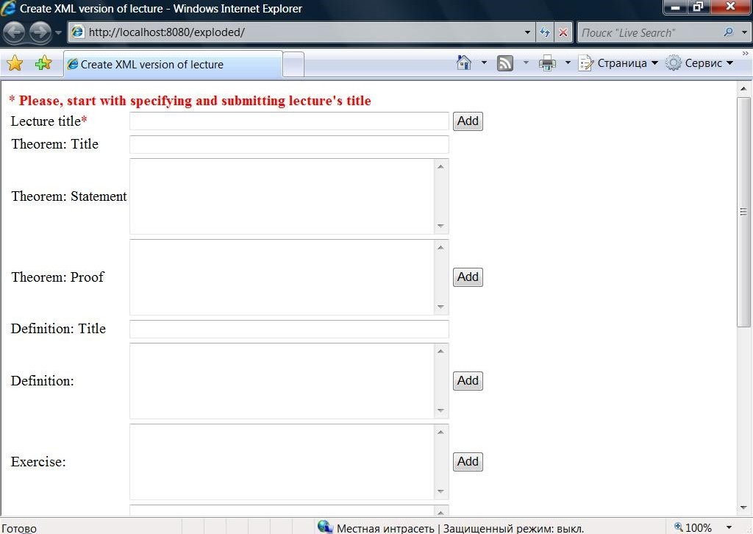
Figure 4.2: Page for automatic creation of XML version of learning material
The author must have an opportunity to add any number of theorems, definitions, and other items.

The result will look e.g. like:
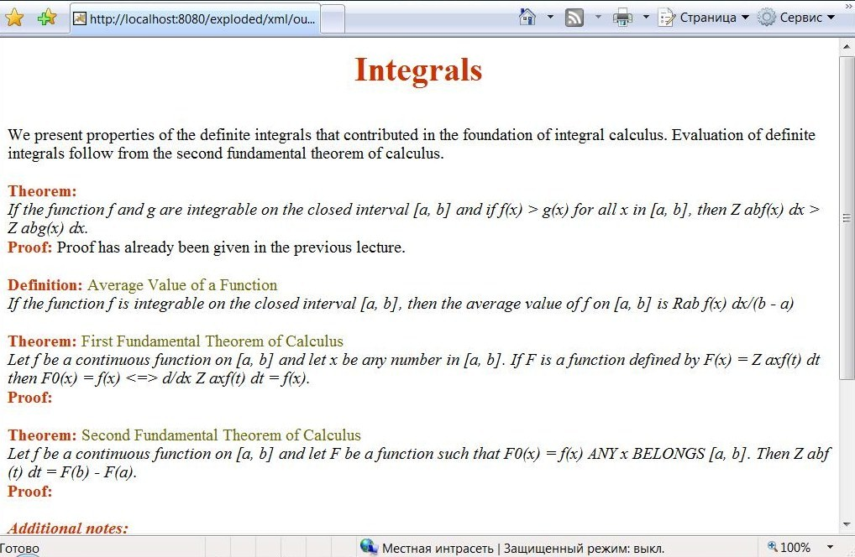

Figure 4.3: Outlook of the created at the previous step page

The ready learning content should be packaged in SCORM package. Lots of tools for creating SCORM courses are available, both commercial and open source. Yet some of them do not support SCORM 2004 (EXE), or do not provide LOM files (MOS Solo). I used a popular open source tool Reload Editor – it has a simple interface and means of generating SCORM learning material packages. The tool is SCORM 2004 conformant, and generates LOM files. Manifest file is partly displayed below:
<metadata>
<schema>ADL SCORM</schema>
<schemaversion>2004 3rd Edition</schemaversion>
<lom:lom>
<lom:general>
<lom:description>
<lom:string language="en-US">Sample Learning Material Package</lom:string>
</lom:description>
</lom:general>
</lom:lom>
</metadata>

<organizations>
<organization identifier="org-88dd736f-2634-0784-2259-86d8016aef58">
<title>Learning Materials</title>
<item identifier="item-dcf33973-ff13-301a-498e-7db84d628fba">
<title>Learning Materials</title>
<item identifier="item-88a15afb-35bb-d545-27eb-eabbbbd2fc37">
<title>Course</title>
<item identifier="item-32e12748-4d96-daf0-ff9d-7cc039898faa">
<title>Topic</title>
<item identifier="item-224b23a9-ffd5-8363-6bf6-b77ff1bda878" identifierref="res-83e5938b-2687-f2db-e5bb-a4d18581f599">
<title>Lecture 1</title>
<metadata>
<lom:lom>
<lom:educational>
<lom:learningResourceType>
<lom:source>LOMv1.0</source>
<lom:value>lecture</value>
</lom:learningResourceType>
<lom:interactivityLevel>
<lom:source>LOMv1.0</source>
<lom:value>very low</value>
</lom:interactivityLevel>
<lom:intendedEndUserRole>
<lom:source>LOMv1.0</source>
<lom:value>learner</value>
</lom:intendedEndUserRole>
</lom:educational>
</lom:lom>
</metadata>
</item>
<item identifier="item-c4d82de6-4f09-6759-b398-dee100d93aa1">
<title>Practice</title>
</item>
</item>
</item>
</item>
</organization>
</organizations>
<resources>

<resource href="lecture.html" identifier="res-83e5938b-2687-f2db-e5bb-a4d18581f599" type="webcontent" adlcp:scormType="sco">
<file href="lecture.html"/>
<dependency identifierref="res-fa560539-8a1d-d8f1-080d-ae1e83f1d8f0"/>
</resource>

<resource identifier="res-fa560539-8a1d-d8f1-080d-ae1e83f1d8f0" type="webcontent" adlcp:scormType="asset">
<file href="lecture.xml"/>
<dependency identifierref="res-2e63f83d-a6ba-b207-8642-818d1fb1ca71"/>
<dependency identifierref="res-bc223f5e-d3df-d055-c943-e7d84858815a"/>
</resource>

<resource identifier="res-2e63f83d-a6ba-b207-8642-818d1fb1ca71" type="webcontent" adlcp:scormType="asset">
<file href="lecture.xsl"/>
</resource>

<resource identifier="res-bc223f5e-d3df-d055-c943-e7d84858815a" type="webcontent" adlcp:scormType="asset">
<file href="lecture.dtd"/>
</resource>

</resources>

Code Illustration 4.1: Part of “imsmanifest.xml”from created SCORM 2004 package

As it can be noticed from the manifest text, mentioned above taxonomy is presented in Organization. The launchable file is “lecture.html” (not lecture.xml, for PDA does not open XML files, so HTML version is generated out of the newly created by the instructor XML one in LMS) that is present in Resources section and marked as “webcontent” of type “SCO”. The launchable resource, which has “href” attribute that indicates that the resource is the one to be launched, depends on the asset, namely on XML version, while the latter depends on DTD and XSLT documents. Lecture organization item refers to the correspondent resource. LOM metadata is used for description of the whole package and a separate organization item.

Moodle has a special module named SCORM/AICC for uploading and publishing SCORM packages.

As it has been predicted, learning material created and organized in such way can be used in the process of intellectualization of the LMS and for m-learning. The distance learning system may suggest several versions of the material document.

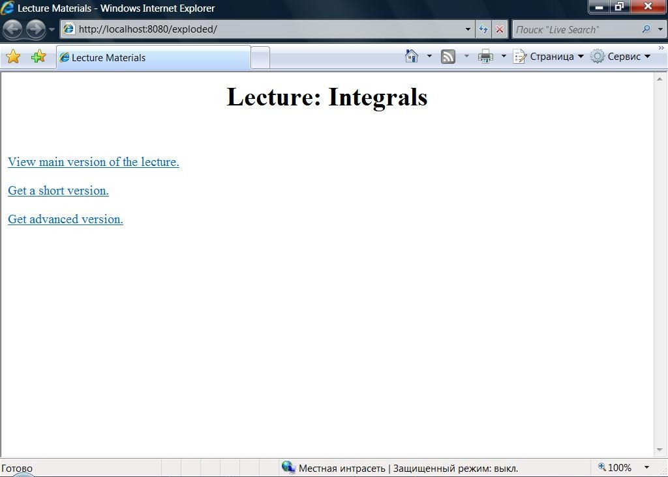

Figure 4.4: Outlook of the page with several suggested versions of material

The main version of the document would be the one created by the teacher, and the short and extended ones will be generated on user’s request.
The main version of the document will contain all main items except for additional comments.
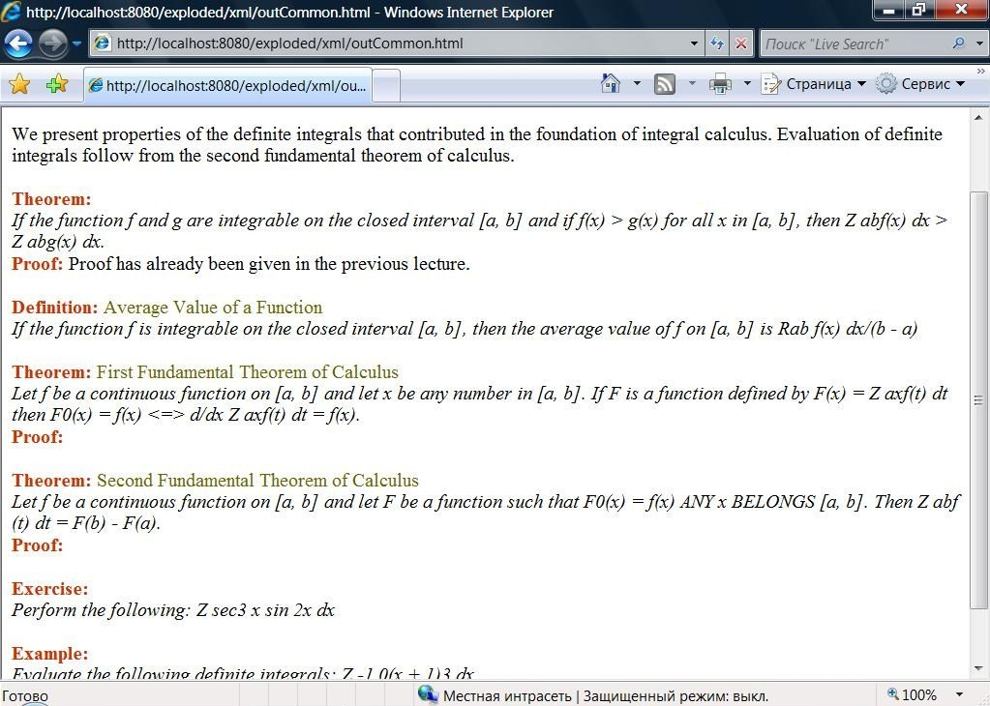
Figure 4.5: Outlook of the main version of the document

The short one would comprise only theorems and definitions in our example.

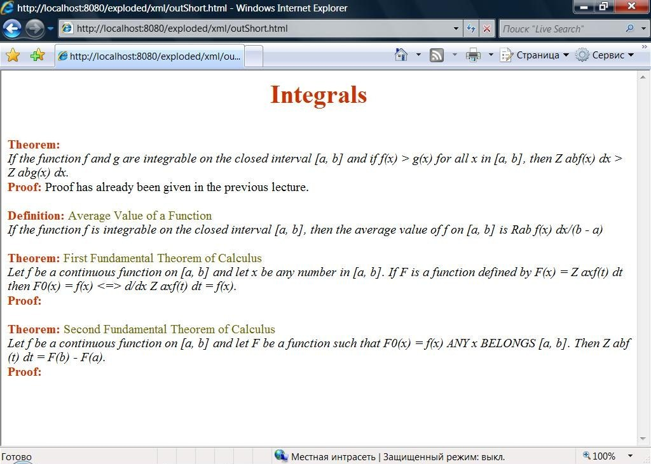
Figure 4.6: Outlook of the short version of the document

For comparison, this is how the same page looks in PDA:

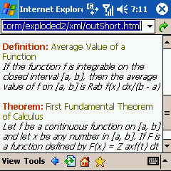
Figure 4.7: Outlook of the short version of the document viewed from PDA
It can be noticed from the above screenshot that even one theorem with a proof most probably would not be seen completely on PDA screen. So, it is obvious that large documents would not be effective for m-learning.

The extended version will contain additional explanations.

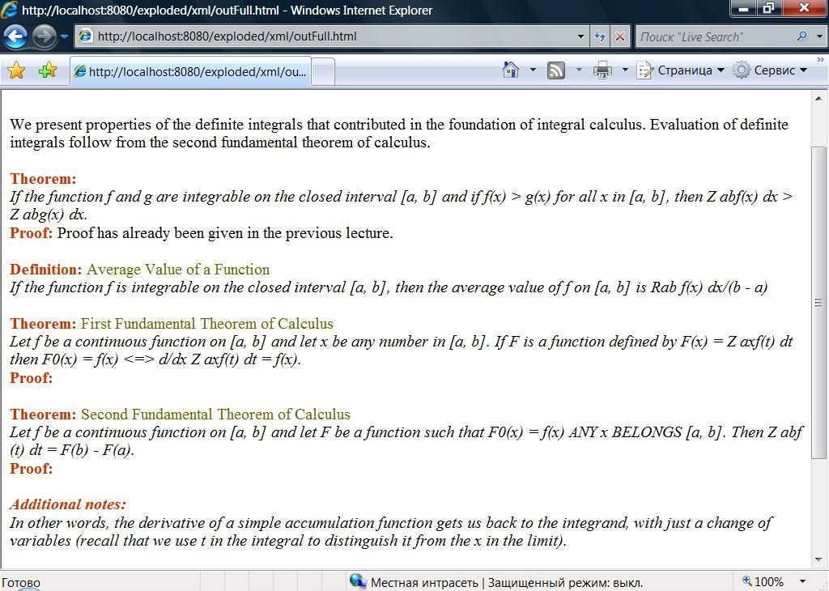
Figure 4.8: Outlook of the extended version of the document

Summary
In the thesis I have investigated main concepts and advantages of SCORM standard. Much research has been done on account of possibility to extend SCORM and provide interoperability of the content.
The suggested by me approach proposes extending of the standard Content Organization in depth by organizing the material by means of Organizations component of the model plus building structured learning content in XML format.
The sample proposed educational material taxonomy can look like the following:
- Learning materials
  - Course
    - Topic
      - Lecture
        - Theorem
          - Name
          - Formulation
          - Proof
        - Definition
          - Name
          - Definition Text
        - Abstract
        - Advanced
        - Exercise
        - Example
          - Task
          - Solution
      - Practice
As far as the leaf item of Content Organization should refer to a resource file according to SCORM, and it is inconvenient to have separate files for each taxonomy item, I suggest leaving “Lecture” as the leaf item in the Organization part, and representing the low level structure by means of XML.
The learning instructor will be proposed an easy to use web form for automatic creation of XML version of his or her material.
The created content will be packed in a SCORM 2004 package and thus be reusable and interoperable.
In prospect of intellectualization of the LMS, we can assume that after the XML version of the learning document is created, an agent will select necessary information for the learner basing on the user’s model, taking into account student’s grades, taken courses. For example, most students will view main version of the document, very successful ones who find the main concepts enough to learn the material will be suggested a short variant with the main information, and weak learners will be provided with a document with additional comments, examples and explanations. In addition, an agent will check the learned by the student material at previous courses, and will suggest again only the key points if the material has already been passed by the learner before.
Certain benefits are proposed by such approach for m-learners. Usually, “mobile” students do not need full materials, but require some hints, key points out of the documents. So, they are suggested a short version with main items of the learning document.

6 References
- e – mentor :: Perspectives for improvement of Distance Learning Environments (SCORM). – http://www.e-mentor.edu.pl/artykul_v2.php?numer=12&id=229
- SCORM module – MoodleDocs. – http://docs.moodle.org/en/SCORM/
- Dublin Core Metadata Initiative (DCMI) – http://dublincore.org/
- IEEE 1484.12.1-2002 Learning Object Metadata Standard.
Available at: http://www.ieee.org/
- IEEE 1484.12.3 Standard for Extensible Markup Language (XML) Schema
Binding for Learning Object Metadata
Available at: http://www.ieee.org/
- Dublin Core Metadata Initiative (DCMI) Education –
www.schemas-forum.org/workshops/ws2/ws2-presentations/DC-Ed.ppt
- ИСПОЛЬЗОВАНИЕ СИСТЕМ МЕТАДАННЫХ ДЛЯ ОПИСАНИЯ ИНФОРМАЦИОННЫХ ОБРАЗОВАТЕЛЬНЫХ РЕСУРСОВ. Харченко А.С. к.т.н. проф. Башмаков И.А. МЭИ(ТУ), г.Москва, Россия. http://iu4.bmstu.ru/konf/2003/sbornik/s1_21.doc
- Learning Technology Standards Observatory –
http://www.cen-ltso.net/Users/main.aspx
- M-learning – Home. – http://www.m-learning.org/index.htm
- В мире насчитывается 4 миллиарда обладателей мобильных телефонов – ОБОЗ. – http://news.oboz.ua/info/2231.htm
- Количество обладателей мобильных телефонов неустанно растет – Мобильник.UA. – http://mobilnik.ua/news/17266.html
- Using Moodle: Parametrization of moodle for supporting m-learning. –http://moodle.org/mod/forum/discuss.php?d=71308
- Дистанційна Освіта // Освітній портал. – http://www.osvita.org.ua/distance/
- SCORM » One Minute SCORM Overview for Anyone. –
http://www.scorm.com/scorm-explained/one-minute-scorm-overview/
- What Is SCORM? – http://www.scorm.com/wp-content/ assets/old_articles/whatisscorm/What%20Is%20SCORM.htm
- SCORM 2004 3rd Edition Overview Version 1.0, Advanced Distributed Learning, October 20, 2006.
Available at: http://www.adlnet.gov/
- SCORM 2004 3rd Edition Content Aggregation Model Version 1.0, Advanced Distributed Learning, October 20, 2006.
Available at: http://www.adlnet.gov/
- IMS Simple Sequencing Behavior and Information Model v1.0 Final
Specification, IMS Global Learning Consortium, Inc., March 2003.
Available at: http://www.imsproject.org/
- SCORM 2004 3rd Edition Run-Time Environment Version 1.0, Advanced
Distributed Learning, October 20, 2006.
Available at: http://www.adlnet.gov/
- Extensible Markup Language (XML) 1.1 . 04 February 2004.
Available at: http://www.w3.org/
- IMS Content Packaging Information Model, Version 1.1.4 Final Specification.
October, 2004.
Available at: http://www.imsglobal.org/
- XML Schema Part 2: Datatypes, W3C Recommendation, 02 May 2001.
Available at: http://www.w3.org/
- XML Base. June 27, 2001 – Available at: http://www.w3.org/
- Simplifed IEEE LOM Schema. –
http://www.ostyn.com/standards/scorm/samples/simplerlomschemadoc.htm
- SCORM 2004 3rd Edition Sequencing and Navigation Version 1.0, Advanced
Distributed Learning, October 20, 2006.
Available at: http://www.adlnet.gov/

